**PRACTICAL – 12**

**AIM: Write a program to perform selective compliment operation on data stored at 4000H corresponding to the data stored at 4001H and store the result at 4002H. Verify the result and write bite wise operation of this program. (XOR)**

**CODE:**

ORG 100H

MOV [4000H], 10101011B

MOV [4002H], 11010101B

MOV AL,[4000H]

MOV BL,[4001H]

XOR AL,BL

RET

**OUTPUT:**

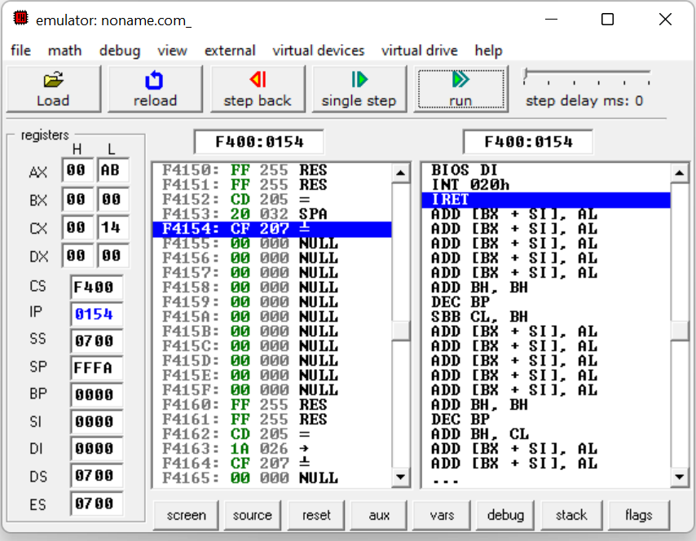

**CONCLUSION:** We learnt how to perform selective compliment operation. By XOR gate.